3 Запросы к БД
3.1 Получение основной информации по заявками
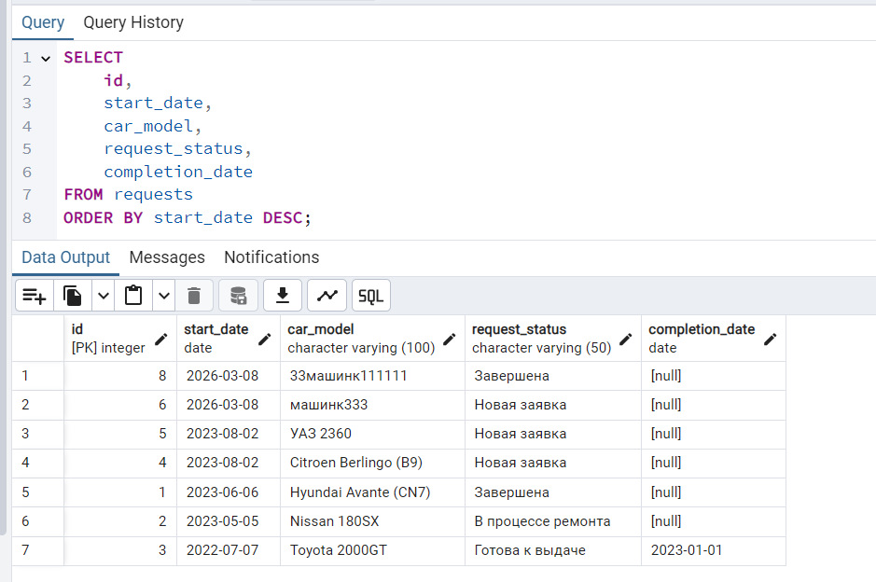
SELECT
id,
start_date,
car_model,
request_status,
completion_date
FROM requests
ORDER BY start_date DESC;
3.2 Статистика по статусу заявок
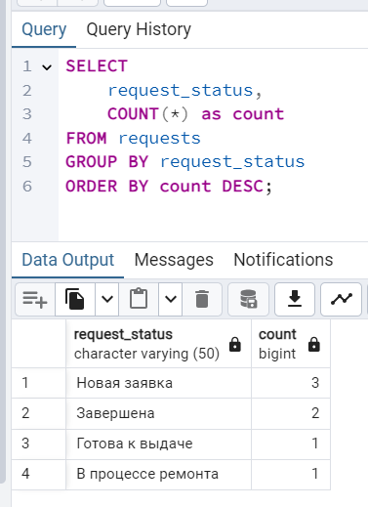
SELECT
request_status,
COUNT(*) as count
FROM requests
GROUP BY request_status
ORDER BY count DESC;

3.3 Расчет среднего времени ремонта
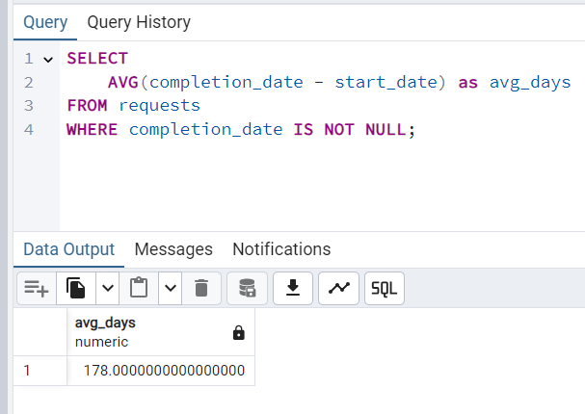

SELECT
AVG(completion_date - start_date) as avg_days
FROM requests
WHERE completion_date IS NOT NULL;

3.4 Заявки определенного мастера
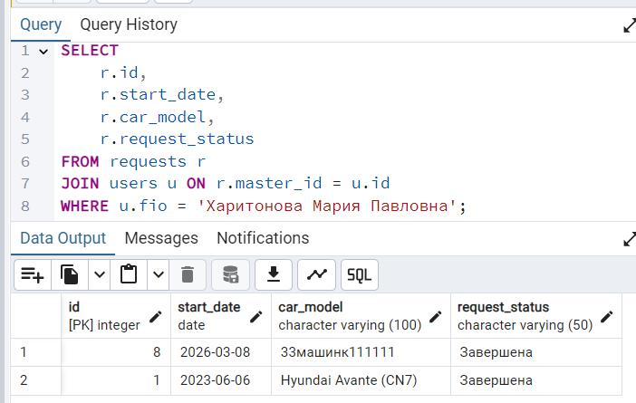

SELECT
r.id,
r.start_date,
r.car_model,
r.request_status
FROM requests r
JOIN users u ON r.master_id = u.id
WHERE u.fio = 'Харитонова Мария Павловна';

3.5 Просмотр комментариев к заявке
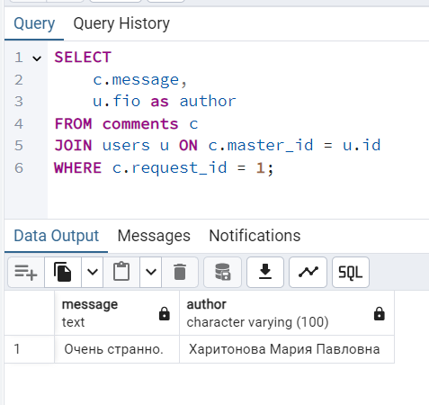

SELECT
c.message,
u.fio as author
FROM comments c
JOIN users u ON c.master_id = u.id
WHERE c.request_id = 1;
3.6 Статистика по проблемам в заявках
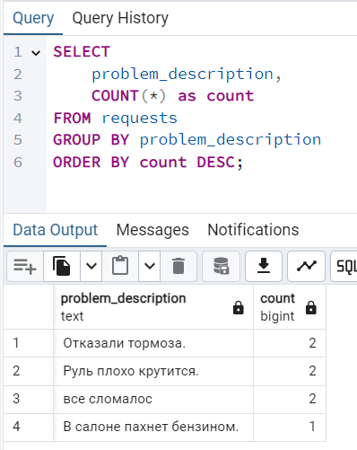
SELECT
problem_description,
COUNT(*) as count
FROM requests
GROUP BY problem_description
ORDER BY count DESC;

